|  |  |
| --- | --- |
| Assessment Title | Assessment 3 – Refine and Implement |

## Competency Details

|  |  |
| --- | --- |
| Unit code/s and title/s | BSBCRT512 - Originate and develop concepts |
| Qualification code/s and title/s | ICT50220 Diploma of Information Technology |
| Business unit/Work group | Business and Arts / IT Studies |

## Instructions

|  |  |
| --- | --- |
| Method/s of assessment | Written (Questioning), Observation (Presentation) |
| Overview of assessment | In this assessment you will create a use-case statement for one part of your concept to promote thinking about logical order of the use of the final product. You will design your user interface keeping in mind the skill level of the target audience. You will create and present a presentation of your concept interface design to the Manager (Lecturer) and your peers. In the presentation you will be assessed on how well the concept design meets the measurable actions and your presentation skills. The feedback given by the Manager (Lecturer) will then be documented and incorporated into the design. The concept is then evaluated for commercialisation viability. Finally, a reflection will be undertaken so that the skills performed can be thought of as being used again and improved on for future projects. |
| Task/s to be assessed | In this assessment you will complete the following tasks:   * Task 1 - Design Concept * Task 2 - Present Concept Design * Task 3 - Document and Implement Feedback * Task 4 - Evaluate Commercialisation * Task 5 - Reflection |
| Time allowed | The submission dates for each assessment are provided in the Study Schedule in the **Home** section in Learn |
| Location of assessment | This assessment may be done during class or outside of class time. It is recommended that Task 2 – Present Concept Design be performed in a class setting. Task 2 – Present Concept Design is recommended to perform in a class setting. Online/external students are to contact your Lecturer via email or in your collaborate session to organise a time for their presentation. |
| Decision making rules | To receive a satisfactory outcome for this assessment you must complete all parts correctly. Word Counts are provided as a guide only |
| Assessment conditions | Skills in this unit must be demonstrated in a workplace or simulated environment where the conditions are typical of those in a working environment in this industry. This includes access to:   * Background information required to evaluate the operational factors that will affect the implementation of concepts. * Opportunities to collaborate with others throughout the concept development process. * Task 1 – Design Concept – is an unsupervised task. * Task 2 – Present Concept Design – is a supervised task. * Task 3 – Document and Implement Feedback – is an unsupervised task. * Task 4 – Evaluate Commercialisation – is an unsupervised task. * Task 5 - Reflection – is an unsupervised task. |
| Resources required | * Microsoft Word * Microsoft PowerPoint * BSBCRT512 – ASDS – Background Information.pptx * Software of choice to develop interface design |
| Result notification and reassessment information | You will be provided feedback and the result for your assignment on TAFESA Learn. You will be and given the chance to resubmit with required corrections only once.  Refer to the TAFE SA [Assessment Policy](https://students.tafesa.edu.au/docs/default-source/apply_enrol/assessment-policy.pdf?sfvrsn=112c415_16) for more information |

# Task 1 – Design Concept

Read the BSBCRT512 – ASDS – Background information.pptx

Q1)

Create a use case statement for your design using the following criteria in the dot points below. For your issue show the use case for the following measurable actions.

Note: Programming and Web Students may use diagrams as alternative to written steps.

Use Case Criteria

* Flow of Events
* Sub Flow
* Alternative Flows
* Quit

Injury Issues

* Tracking employee details
* Reinforcement exercises – and number of attempts
* Final Assessment – and number of attempts
* Saving above data

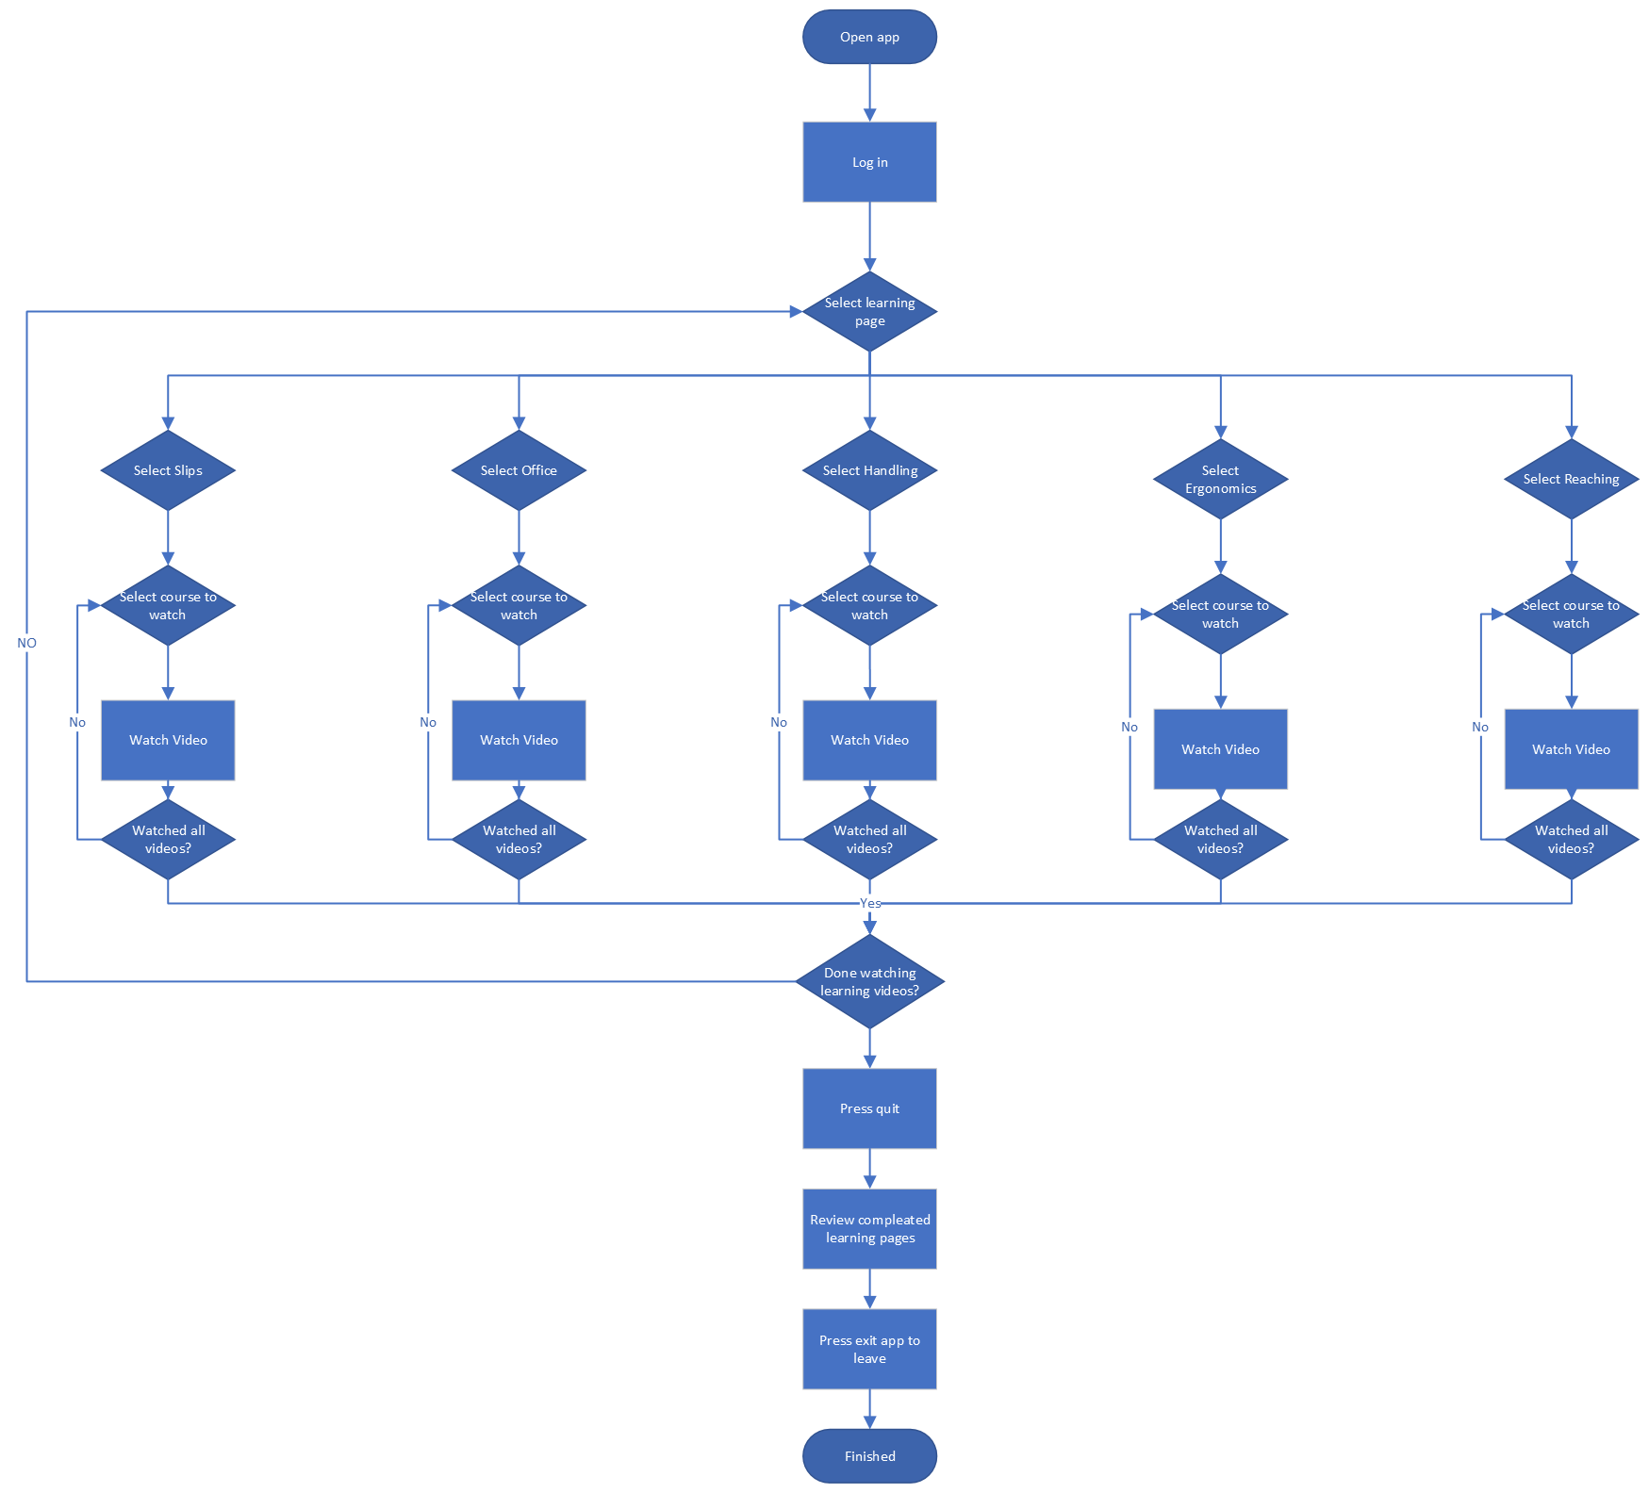

Using your chosen software for your chosen issue, develop the Concept Interface. You will need to present your interface to the Manager once complete. Your interface must address all the measurable actions agreed to in Assessment 1, Define Scope.

Q2)

Describe how your design is suitable for the target audience. In your answer provide specifics of what you believe the level of computer literacy is of the target audience and how that aligns to the computer skill level needed of the users of your system. (Approx. 10 - 15 words)

The design is suitable for the target audience as It is easily navigated and only requires a basic knowledge of how to use a phone

Note: If your target audience is beginner level then you should present your design to a beginner level to see if they would be able to understand it and use it, once fully developed. (Do you have someone in your family that could give you this feedback?) You may be asked about this in your presentation.

# Task 2 - Present Concept Design

Create a PowerPoint Presentation. The requirements of the presentation are listed below.

* Your demonstration should be no longer than 4 minutes.
* Screenshots of every concept interface you have planned, each on a different slide. (No more than 10 slides)
* A demonstration and describing discussion that you will present as to how each measurable outcome for your issue has been met. (Your measurable actions need to be listed on an appropriate slide)
* A demonstration and describing discussion that you will present as to how your design can incorporate the practical and operational requirements.
* Use thoughtful and challenging opinions such as speaking clearly, standing firm on your design, and able to justify it with a good argument.
* You must encourage your audience to ask questions at the end of your presentation.
* You must be prepared to answer questions from the Manager (Lecturer) with substantiated answers that support your design opinions.
* Save your presentation into a folder named BSBCRT512 and name it as Task 2 Concept Design.
* In your folder, make a copy of the Task 2 Concept Design presentation and name it as Task 3 Concept Feedback ready for Task 3.
* You must record feedback given by your Lecturer as you will need to document it for Task 3.
* Note: During your presentation, your oral presentation skills will be assessed on how you use language and non-verbal features to present an engaging presentation for your audience. Non-verbal features include eye-contact with audience, smiling, positive posture, tone of voice and normal speed of speaking.

Select the best method to present and explain your design to the internal stakeholder (your Lecturer) and to external stakeholders (your class peers). The choices of methods are either on campus classes or virtual classes, if you are studying this subject externally you can ask your Lecturer to join a virtual class session. External students may also video record the presentation with an audience of two other people willing to ask questions and submit to your Lecturer to review and they will provide further feedback for Task 3. If you are recording video, it cannot be just audio as you are being assessed on non-verbal communication, please refer to the requirements above.

# Task 3 – Document and Implement Feedback

Document the feedback given by your Lecturer, according to the ITWorks organisational requirements found in the BSBCRT512 – ASDS – Background information.pptx

Using your Task 3 Concept Feedback.pptx that you prepared in Task 2, modify the screen shots of your Design Concept to show the changes you have implemented according to feedback given, include a new heading in Project Plan named Feedback and document the feedback given under that heading.

Save Task 3 Concept Feedback.pptx in your BSBCRT512 folder.

# Task 4 – Evaluate Commercialisation

Determine whether your concept design, if it were a fully functional and implemented program, would be viable to commercialise. Refer to your previous SWOT Analysis and Background Information to assist. Evaluate commercialisation according to the following criteria: (Approx. 10 words each written criteria)

* Is it suitable for wider audiences, in other words, for companies other than ITWorks?
* Market readiness – according to how many similar products exist.
* Intellectual Property registration and cost – Find costings (Design rights - Australia only) – Provide URL only of a reliable source.
* Considering the above, in your opinion should ITWorks commercialise this idea? Why?

# Task 5 – Reflection

On reflection of your Concept Design Project, discuss the following criteria:

* Reflect on the development of your design, do you believe it will or will not work and why? (Approx. 20 words)
* What two key concepts used in planning this project would you use in future projects?
* What two key principles of designing this project could you adapt to future projects?
* Which two techniques have you used to generate creative ideas for a solution that can be then translated to a workable design?

Upload your submission to Learn:

* Folder named BSBCRT512 which contains:
* Task 2 Concept Design.pptx
* Task 3 Concept Feedback.pptx
* ITWorks Project Plan
* This assessment document with your answers to questions.